**Will the Wind Blow it Investigation?**

We have been looking at the story of The Three Little Pigs. We decided to look at different materials to see if they could be blown down.

We had 10 different objects made out of a range of materials.

**The Prediction:**

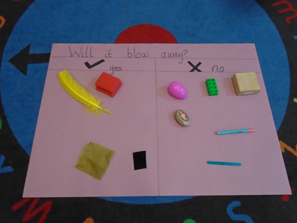

**The Testing of the Objects:**

We used a hairdryer to act as the Wolf blowing the materials.

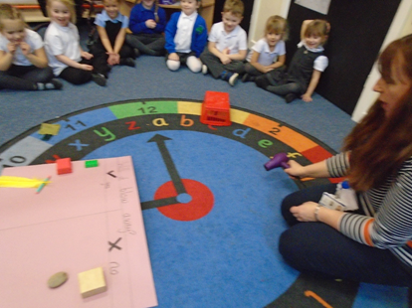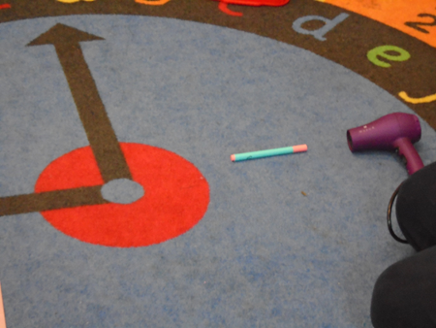

We also discussed that depending on which way round the objects were positioned may result in the object moving or not moving. We demonstrated this with the pen.

**The Results: Testing our own objects:**

